Unit 18

Leave / lose

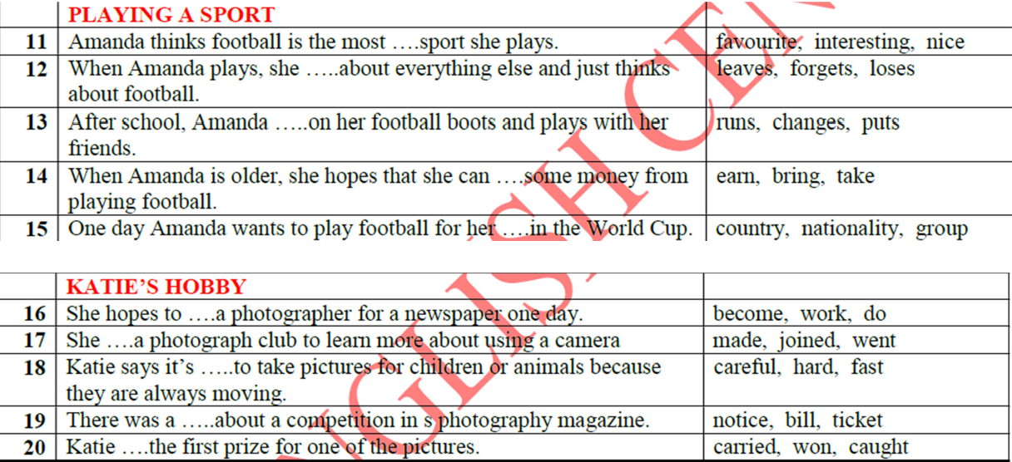

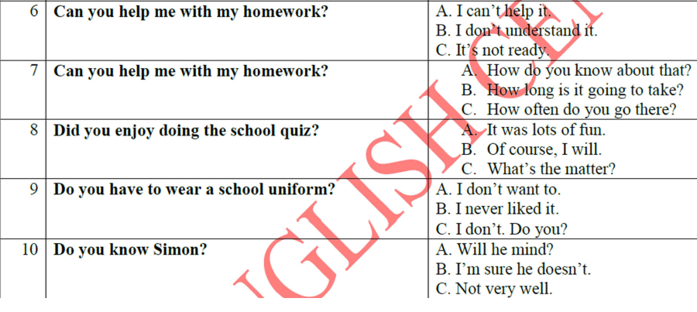

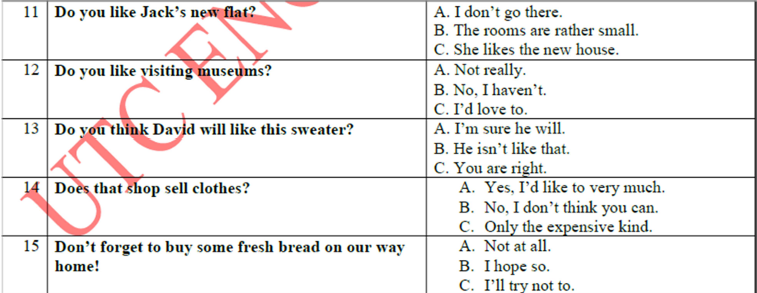

Would like = muon

Like ving : thich

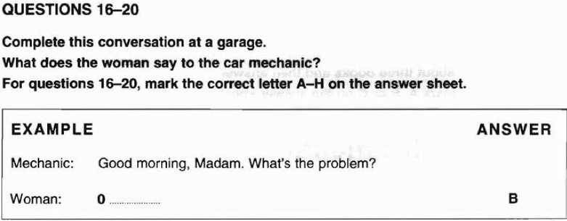

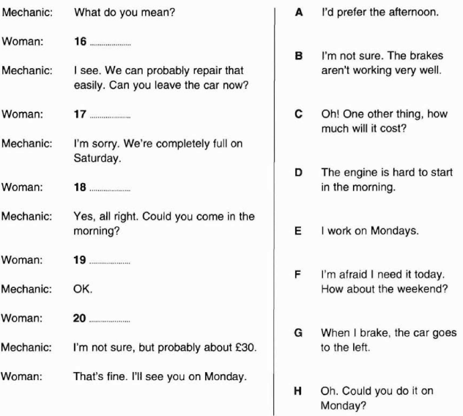

Practice 2:

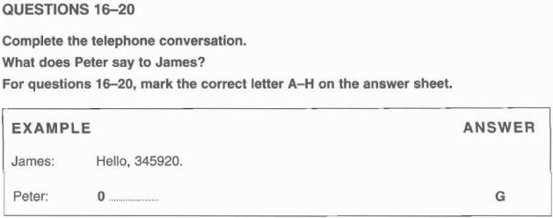

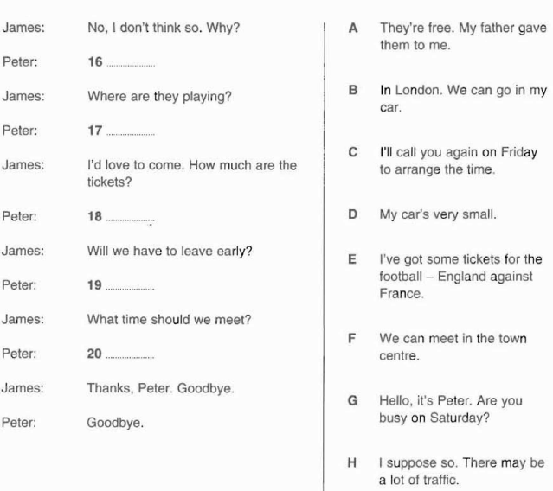

Reading part 4:

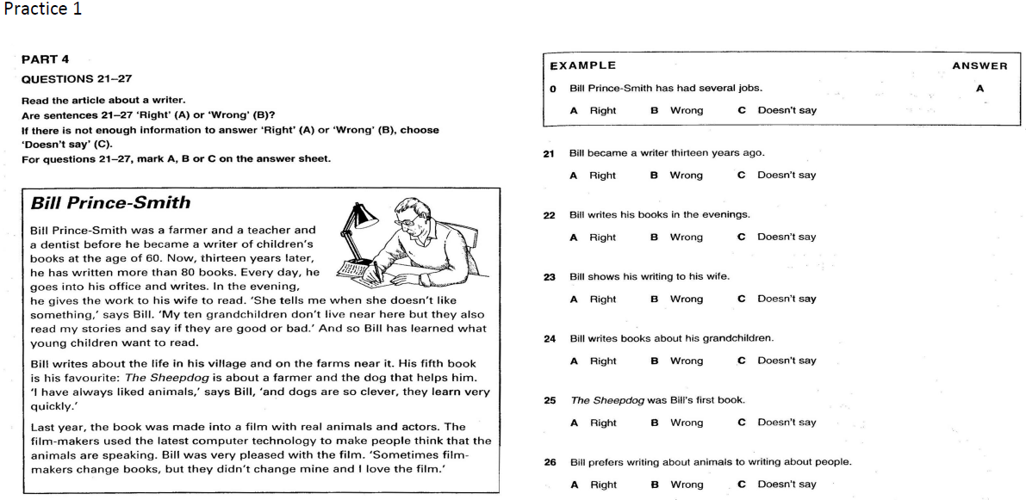



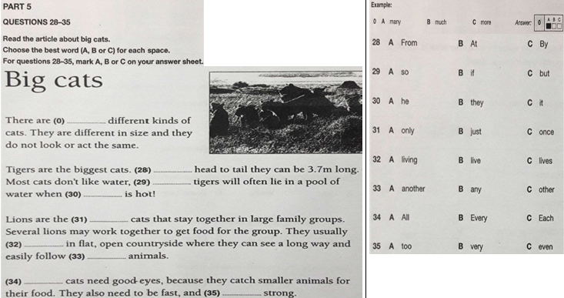

Writing part 6 (week6)

1. You can catch a train from this place s _ _ _ _ _ _ (station)

2. You and your family can sleep here if you are on holiday h _ _ _ _ hotel

3. You can buy things outside in the street here m _ _ _ _ _ market

4. I will repair your car for you m _ _ _ _ _ _ _ mechanic

5. If you want to change the colour of your room, I will do it for you p _ _ _ _ _ _ painter

6. I help my boss by answering the phone, making appointments and writing letters s _ _ _ _ _ _ _ _ secretary

7. This shows what people can eat in a restaurant m _ _ _ menu

8. You can write in this at the end of each day d _ _ _ _ (diary)

9. You can send this or get this kind of message on your mobile t _ _ _ text

10. You write this and then post it in an envelope l _ _ _ _ _ letter

11. A married man is called this by his wife h _ _ _ _ _ _ (husband)

12. You can learn from these people in your family because they are much older than you g _ _ _ _ _ _ _ _ _ _ _ (grandparents)

14. This is what you are before you get married s _ _ _ _ _ (single)

15. If you have children, the girl is called this d _ _ _ _ _ _ _ (daughter)

16. This is written on your passport and is usually the same for one family s _ _ _ _ _ _ (surname/ family name)

17. I help people to learn things t _ _ _ _ _ _ (teacher)

18. You wash yourself with soap and water in this s _ _ _ _ _ shower

19. You look through this to see outside w _ _ _ _ _ (window)

20. People often put books or flowers on this s _ _ _ _ shelf

**Huong dan phan noi so 1 (speaking part 1)**

* **5 points**
* **Personal information**
* **Q-A.**

**NOI DUNG:**

1. **Name?**

**What’s your name? => My name is …**

**What is your full name? => My full name is..**

**How do you spell your name?**

* **It is T_U_N_G**

1. **Age?**

**How old are you? => I am 20/ 21 (years old)**

**When were you born? => I was born in 1999/ 2000.**

1. **Job?**

**What’s your job? = what do you do?**

* **I am a student at the UTC.**
* **What subject do you like most? = what is your favorite subject?**
* **I like (Maths/ English…) most because it is very interesting.**

1. **Hobby?**

**What is your hobby? = what do you often do in your free time? = what do you like doing in your free time?**

* **I like Ving (listening to music, watching TV, reading books…)**

1. **Family?**

**How many people are there in your family?**

* **There are 5 people in my family. They are my parents, my brother, my sister and me.**

**(name, age, job, hobby…)**

1. **Mot so cau hoi phan ung.**

* **Do you have a laptop? Yes, I do. No, I don’t.**

**(I use it to learn English/ but I hope I can have one in the future)**

* **What did you do yesterday?**

**I went shopping with my friend and I bought a T-shirt.**

* **What will you do tomorrow?**
* **What are you going to do tomorrow?**
* **I will go home and visit my parents.**
* **I will stay at home and sleep.**
* **Cau hoi dua ra quan diem ve 1 vd:**

**What do you think of music? Sports? English?...**

**I think it is (good, bad, easy, difficult, interesting, boring…)**

* **Liet ke 10 cau hoi lq den tt ca nhan (doc troi chay 10 cau hoi do)**
* **Tap tra loi cac cau hoi ma minh dua ra.**

**Practice 7:**

**41 told – 42. Needed / had 43. Are 44. A 45 the 46. Were**



**Homework**

**Practice 8:**

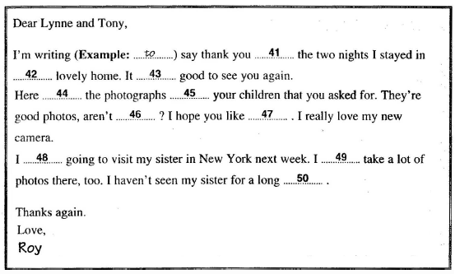

**Practice 9:**



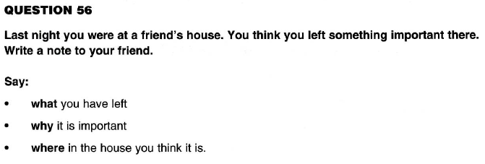

|  |  |
| --- | --- |
| LISTEINING |  |